31.50: a) Since the voltage drop between any two points must always be equal, the parallel LRC circuit must have equal potential drops over the capacitor, inductor and resistor, so 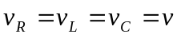. Also, the sum of currents entering any junction must equal the current leaving the junction. Therefore, the sum of the currents in the branches must equal the current through the source: 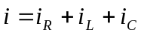.

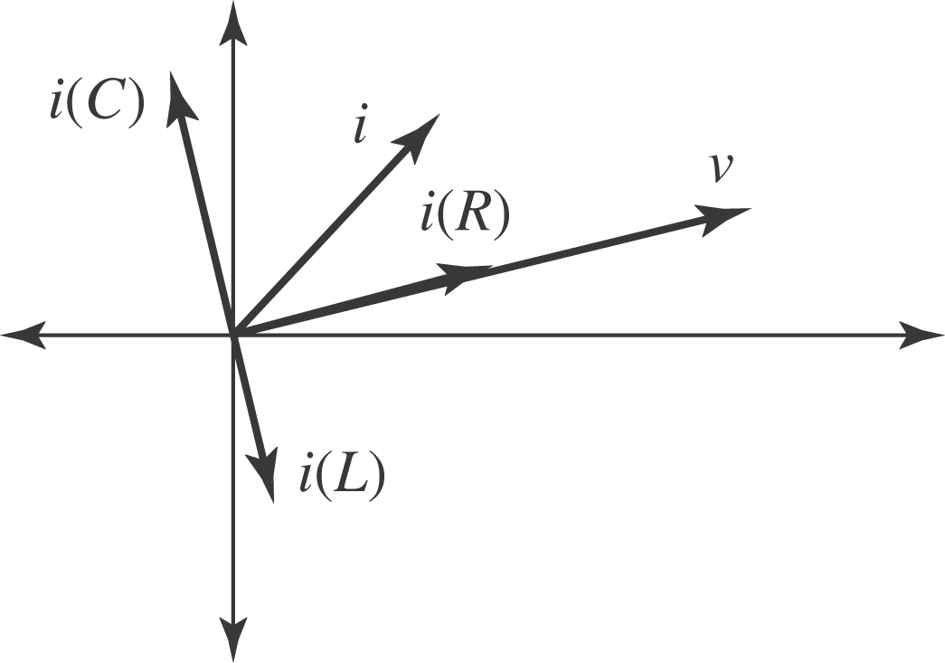

b) 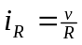 is always in phase with the voltage. 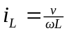 lags the voltage by 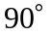, and 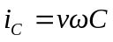 leads the voltage by .
c) From the diagram,
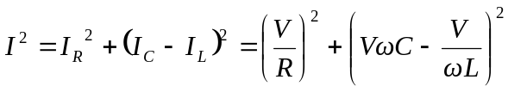
d) From (c): 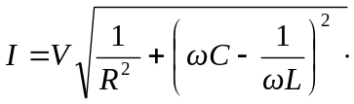 But
